Contact
Kathrin Fleuchaus
Marketing Communications
Coperion GmbH
Theodorstraße 10
70469 Stuttgart/Germany

Telephone +49 (0)711 897 25 07
kathrin.fleuchaus@coperion.com
www.coperion.com


Press Release

Ten STS Mc PLUS Twin Screw Extruders to Boost Capacity Upgrade of South China’s Modified Plastics Leader
Coperion and Guangdong Chuangyongjia Sign Major Equipment Purchase Agreement at Chinaplas 2026
Stuttgart, April 2026 – During Chinaplas 2026 (Shanghai, April 21–24), Coperion (Nanjing) Machinery Co., Ltd. and Guangdong Chuangyongjia New Materials Co., Ltd. formally signed an equipment purchase agreement. Chuangyongjia will acquire ten Coperion STS Mc PLUS twin screw extruders for the compounding of high-performance engineering plastics. The signing took place at Coperion’s booth F98 in Hall 2.1 at this year’s Chinaplas.
In 2025, Guangdong Chuangyongjia New Materials announced a headquarters expansion project. Upon completion, the new campus will greatly enhance its R&D and manufacturing capabilities in specialty engineering plastics. The introduction of ten Coperion STS Mc PLUS extruders represents a key equipment investment in Chuangyongjia’s new campus capacity layout.
Guangdong Chuangyongjia New Materials has nearly 30 years of expertise in engineering plastic modification and has become a benchmark enterprise in South China’s modified plastics industry. Its product portfolio covers high performance engineering plastics including PA, PPS, PPO, PC, PPA, PP, ABS, PBT, and POM, widely used in electronics & electrical appliances, new energy vehicles, photovoltaics, energy storage, and aerospace.
Customer Background: Strategic Leap from Traditional Modification to New Energy Segments
Founded in 1997 as Dongguan Huangjiang Weijia Plastic Factory, Guangdong Chuangyongjia New Materials Co., Ltd. has nearly 30 years of expertise in engineering plastic modification and has grown into a benchmark enterprise in South China’s modified plastics industry. Its product portfolio covers high-performance engineering plastics including PA, PPS, PPO, PC, PPA, PP, ABS, PBT, and POM, widely used in electronics and electrical appliances, new energy vehicles, photovoltaics, energy storage, and aerospace.
Chuangyongjia has jointly established a New Materials Joint Innovation Center with South China University of Technology and holds more than 20 invention patents. In 2024, the company acquired industrial land in Xiegang Town, Dongguan. In 2025, its headquarters expansion project with a total investment of 260 million RMB was officially launched. Upon completion, the new campus will significantly enhance its R&D and manufacturing capabilities in specialty engineering plastics. The introduction of ten Coperion STS Mc PLUS extruders represents a key equipment investment in Chuangyongjia’s new campus capacity layout.
STS Mc PLUS: High Torque, Low Shear, Scalable Processing
Coperion’s STS Mc PLUS series twin screw extruders are built on the fourth-generation STS technology platform. Taking the STS 65 Mc PLUS as an example, it delivers a specific torque of up to 13.6 Nm/cm³ and a maximum screw speed of 900 min⁻¹. Compared with the previous generation, output can be increased by up to 20%, while shear stress and melt temperature during compounding are significantly reduced, further improving end-product quality.
Core improvements to the STS Mc PLUS lie in comprehensive optimization of the drive section: higher-power motors, gearboxes specifically engineered for high torque, and high-performance material shafts ensure efficient torque transmission from the gearbox to the process section. The high fill level in the process section not only improves mixing quality but also enables gentle handling of materials – critical for glass fiber reinforcement, flame-retardant modification, and high-temperature engineering plastic compounding applications served by Chuangyongjia.
The STS Mc PLUS series is assembled at Coperion’s Nanjing plant, equipped with high-quality Coperion brand gearboxes manufactured in Europe, fully compliant with CE standards and Coperion’s global unified quality criteria. Local production delivers shorter delivery times, more competitive cost structures, and responsive after-sales service to Chinese customers.
Statements from Both Parties
Zeng Xueliang, General Manager of Guangdong Chuangyongjia New Materials Co., Ltd., stated: “Chuangyongjia is at a critical transformation stage. Our customer base is rapidly expanding from traditional home appliances and photovoltaics to new energy vehicles and energy storage, where downstream applications impose unprecedented high requirements for batch consistency, uniform dispersion, and performance stability of modified materials. In evaluating equipment solutions, Coperion’s STS Mc PLUS – with its gentle material handling under high torque output and reliable process scalability from R&D to mass production – aligns perfectly with our strategic direction. These ten units will be deployed at our new campus, marking a watershed for Chuangyongjia as we shift from ‘scale-driven’ to ‘quality-driven’ growth.”
Joanne Shen, General Manager of Coperion (Nanjing) Machinery Co., Ltd. commented: “Mr. Zeng Xueliang’s understanding of material processes is truly impressive. Chuangyongjia’s choice reflects the profound transformation underway in China’s modified plastics industry – leading enterprises are no longer satisfied with ‘being able to produce’ but strive to ‘produce the best’. The new energy vehicle and energy storage industries impose extremely stringent requirements on the reliability and consistency of engineering plastics, directly driving the iteration of compounding equipment from general-purpose to high-performance models. With a manufacturing and service team of nearly 400 employees in Nanjing, combined with the technology platform of our German headquarters, Coperion can provide Chinese customers with solutions of European-equivalent quality, yet with delivery and services more closely aligned with the market. This order for ten STS Mc PLUS extruders is a powerful endorsement of this strategy.”

About Coperion
Coperion (www.coperion.com) is a global industry and technology leader in compounding and extrusion systems, size reduction, washing, separating, drying, agglomeration, feeding, weighing, material handling and pneumatic conveying systems, as well as milling, mixing, thermal processing, dust collection and other services. Coperion develops, produces, and services plants, machinery, and components for the plastics and plastics recycling, chemical, battery, minerals, food and pharmaceutical industries. Coperion employs more than 5,000 people in its divisions, Performance Materials and Food, Health & Nutrition - at over 50 sales and service locations worldwide.

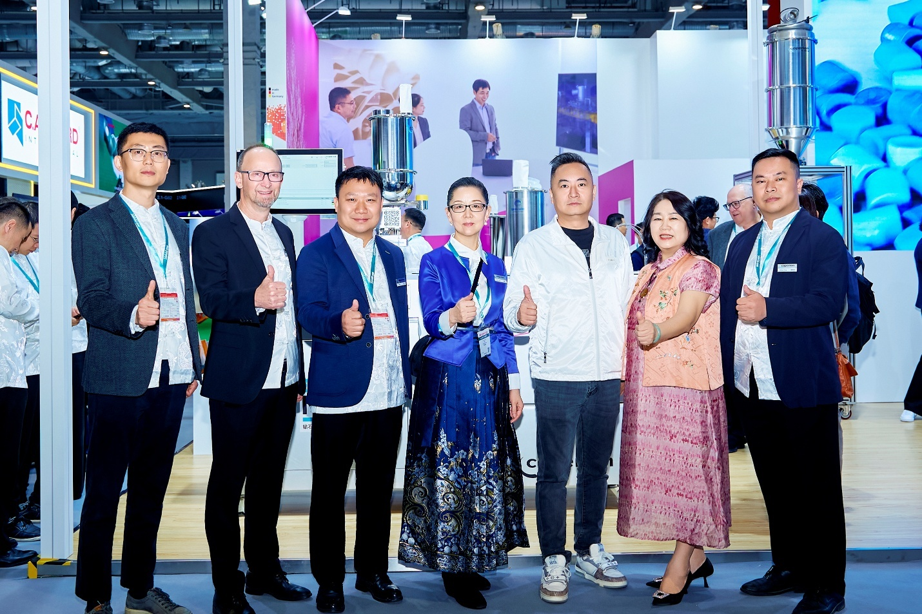

Coperion and Guangdong Chuangyongjia signed a major equipment purchase agreement for ten STS Mc PLUS twin screw extruders at Chinaplas 2026.
Photo: Coperion, Stuttgart Germany

